# Assignment - 3 Bucket And Watson assistant

|  |  |
| --- | --- |
| Assignment Date | 5 November 2022 |
| Student Name | Leelavinothini B |
| Student Roll Number | 951919CS045 |
| Maximum Marks | 2 Marks |

**Questions:**

# Create a Bucket in IBM object storage.

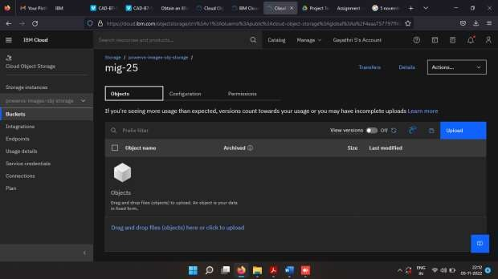

1. **Upload an 5 images to ibm object storage and make it public. write html code to displaying all the 5 images.**

# Index.html

<!DOCTYPE *html*>

<html *lang*="en">

<head>

<meta *charset*="UTF-8">

<meta *http-equiv*="X-UA-Compatible" *content*="IE=edge">

<meta *name*="viewport" *content*="width=device-width, initial-scale=1.0">

<title>Smart Fashion shop </title>

<style>

body {

background-color: aqua; display: flex;

align-items: center;

justify-content: center; flex-direction: column;

}

img {

height: 240px; border-radius: 10px; margin: 10px;

}

</style>

</head>

<body>

<h1>Wellcom To Fashion Store</h1>

<div>

<img *src*="https://imagebucket-vk.s3.ap.cloud-object- storage.appdomain.cloud/alex-haigh-fEt6Wd4t4j0-unsplash.jpg"

*alt*="Dress" *srcset*="">

<img *src*="https://imagebucket-vk.s3.ap.cloud-object- storage.appdomain.cloud/faith-yarn-Wr0TpKqf26s-unsplash.jpg"

*alt*="Dress" *srcset*="">

<img *src*="https://imagebucket-vk.s3.ap.cloud-object- storage.appdomain.cloud/haryo-setyadi-acn5ERAeSb4-unsplash.jpg"

*alt*="Dress" *srcset*="">

<img *src*="https://imagebucket-vk.s3.ap.cloud-object- storage.appdomain.cloud/ryan-hoffman-6Nub980bI3I-unsplash.jpg"

*alt*="Dress" *srcset*="">

<img *src*="https://imagebucket-vk.s3.ap.cloud-object- storage.appdomain.cloud/yves-monrique-LR99Ho2eIec-unsplash.jpg"

*alt*="Dress" *srcset*="">

</div>

</body>

</html>

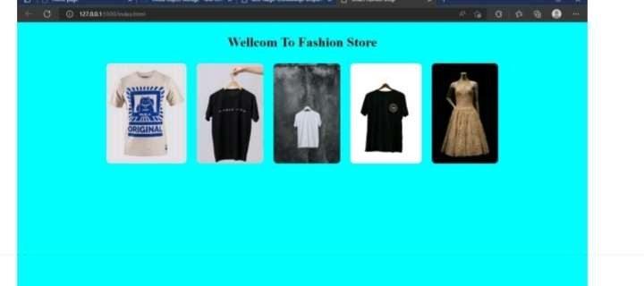

# Upload a css page to the object storage and use the same page in your HTML code.

<!DOCTYPE *html*>

<html *lang*="en">

<head>

<meta *charset*="UTF-8">

<meta *http-equiv*="X-UA-Compatible" *content*="IE=edge">

<meta *name*="viewport" *content*="width=device-width, initial-scale=1.0">

<title>Smart Fashion shop </title>

<link *rel*="stylesheet" *href*="https://imagebucket-vk.s3.ap.cloud-object- storage.appdomain.cloud/style.css">

</head>

<body>

<h1>Wellcom To Fashion Store</h1>

<div>

<img *src*="https://imagebucket-vk.s3.ap.cloud-object- storage.appdomain.cloud/alex-haigh-fEt6Wd4t4j0-unsplash.jpg"

*alt*="Dress" *srcset*="">

<img *src*="https://imagebucket-vk.s3.ap.cloud-object- storage.appdomain.cloud/faith-yarn-Wr0TpKqf26s-unsplash.jpg"

*alt*="Dress" *srcset*="">

<img *src*="https://imagebucket-vk.s3.ap.cloud-object- storage.appdomain.cloud/haryo-setyadi-acn5ERAeSb4-unsplash.jpg"

*alt*="Dress" *srcset*="">

<img *src*="https://imagebucket-vk.s3.ap.cloud-object- storage.appdomain.cloud/ryan-hoffman-6Nub980bI3I-unsplash.jpg"

*alt*="Dress" *srcset*="">

<img *src*="https://imagebucket-vk.s3.ap.cloud-object- storage.appdomain.cloud/yves-monrique-LR99Ho2eIec-unsplash.jpg"

*alt*="Dress" *srcset*="">

</div>

</body>

</html>

# Output:-

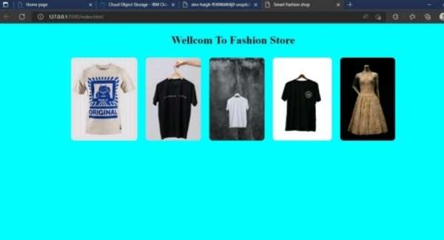

1. **Design a chatbot using IBM Watson assistant for hospital. Ex: User comes with query to know the branches for that hospital in your city. Submit the web URL of that chat bot as a assignment.**

# Url :- [chatbot link](https://web-chat.global.assistant.watson.appdomain.cloud/preview.html?backgroundImageURL=https%3A%2F%2Feu-gb.assistant.watson.cloud.ibm.com%2Fpublic%2Fimages%2Fupx-2187bdc6-3463-4336-a0e5-105ac4d979db%3A%3A31897cd3-e620-4527-80d8-c93d7c618899&integrationID=fd3649a9-27f7-43a9-96c0-5ca4d5bbf885&region=eu-gb&serviceInstanceID=2187bdc6-3463-4336-a0e5-105ac4d979db) <- click Image-

**5 .Create Watson assistant service with 10 steps and use 3 conditions in it. Load that script in HTML page**

